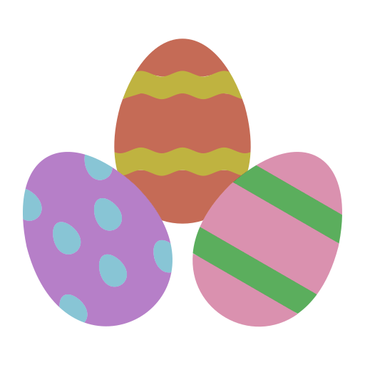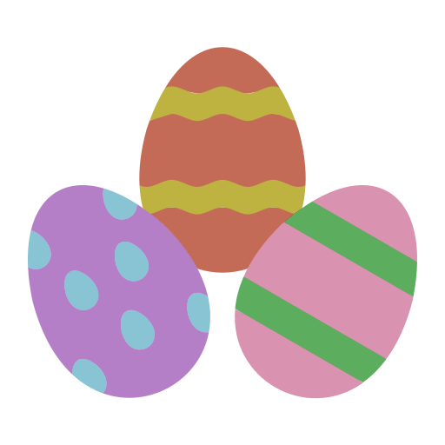**Chocolate Festival Easter Egg Hunt**

**Are you looking for things to do over the Easter Holidays?**

**Come and join in our Easter Egg Hunt!**

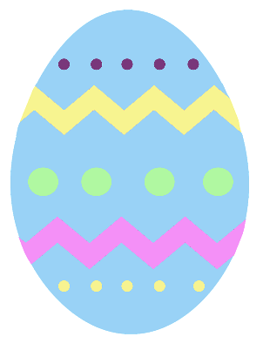Throughout the 2 weeks holiday there will be 12 eggs to hunt for in the windows of different houses in Clare Road, Vauxhall Drive, Brandon Road, College Road, George Road, School View and Clydesdale Road.

All you have to do is find the houses and write down the letter that is on the egg which should be easy to see from the path outside. Then rearrange the letters to make the Easter sentence.

_ _ _ _ _ _ _ _ _ _ _ _

**Bring your answer to the Chocolate Fun Day on 26th April at Christ Church between**

**10am and 2pm to receive your prize.**

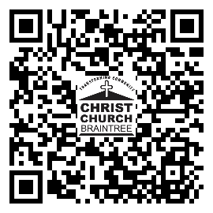**Have Fun!**